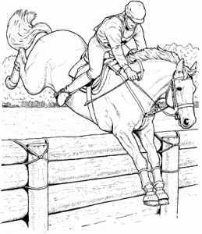
Morpeth Hunt Team Relay & Showjumping Competition
at Needless Hall Moor, Morpeth, NE61 4JF
On Saturday 24th August 2019, starting at 1.30pm
By kind permission of Mr S Anderson & Mr J Cookson

SJ Classes
1. Lead rein, jumps will be very small
2. Unassisted, jumps not to exceed 55cm
3. Jumps not to exceed 65cm
4. Jumps not to exceed 75cm
5. Jumps not to exceed 85cm

Team Relay Classes
Team relay (teams of 3) to jump over a course of rustic and coloured fences, judged on time
6. Lead rein, jumps will be very small
7. Unassisted, jumps not to exceed 55cm
8. Jumps not to exceed 65cm
9. Jumps not to exceed 75cm
10. Jumps not to exceed 85cm
11. Jumps not to exceed 95cm

Rosettes to 6th place
Entries close on Thursday 22nd August
Please send entries to Michelle Macaulay, North Sharperton Steads, Morpeth, NE65 7AE
If you’d like to enter via email and pay by bacs please email web@morpethfoxhounds.co.uk

Rules
1. All competitors must wear a BS riding hat whilst mounted.
2. The organisers or any persons acting on their behalf do not accept any liability for any loss, damage, accident, injury to horses, ponies, riders, spectators or property whatsoever in connection with or arising from this event.
3. Dogs must be kept on a lead at all times.
4. The judges’ decision is final. Any objections / complaints must be lodged in writing to the secretary with a deposit of £20 (returnable if the objection / complaint is upheld).
5. We recommend that body protectors are worn for all classes.
Name | Horse/Pony | Class | Entry Fee
 |  | Total Fee

Entries - Classes 1 – 5 £6 , Classes 6 – 11 £15 / team
Entries close Thursday 22nd August
Please send entries to Michelle Macaulay, North Sharperton Steads, Morpeth, NE65 7AE
Cheques payable to Morpeth Foxhounds (please email web@morpethfoxhounds.co.uk if you’d like to enter via email and pay by bacs)

Name______________________________________________________
Address____________________________________________________
___________________________________________________________
Telephone No._______________________________________________
Email ______________________________________________________

