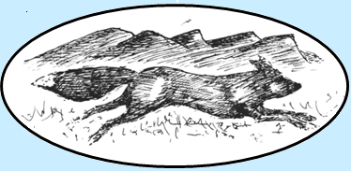
The Morpeth Foxhounds Dog Show
16th June 2019
Needless Hall Moor, Morpeth NE61 4JG

Terrier classes: classes will be split into 2 sections a) dogs b) bitches
- Any terrier puppy (under 12 months)
- Jack Russell terrier
- Border terrier
- Lakeland/Fell terrier
- Any terrier
- Any entered terrier
- Any veteran terrier (over 7yrs)
- Any pair of terriers
- Champion terrier – best terrier in show (for winners of classes 1 – 7)
Lurcher classes: classes will be split into 2 sections a) dogs b) bitches
- Lurcher puppy (under 12 months)
- Smooth Lurcher under 23”
- Smooth Lurcher over 23”
- Rough Lurcher under 23”
- Rough Lurcher over 23”
- Entered Lurcher
- Veteran Lurcher (over 7yrs)
- Any pair of Lurchers
- Champion Lurcher – best Lurcher in show (for winners of classes 10 – 16)
Family Dogs:
- Best child handler
- Best puppy (under 12 months)
- Best dog
- Best bitch
- Best veteran (>7yrs)
- Best trick

All classes £1 to enter. Entry on the day. The judge’s decision is final in all classes.

